**Leader Overview**

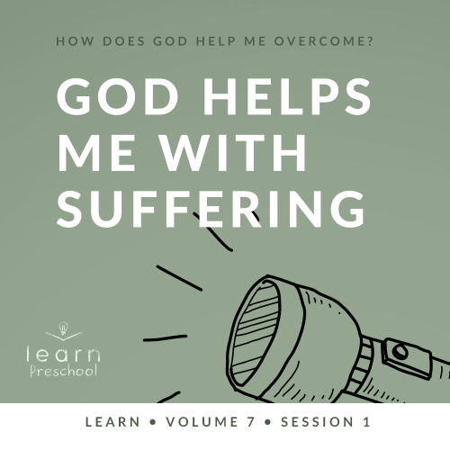

**Volume Overview**

**How does God help me overcome?**

*Life can be full of challenges. Thankfully, when we make the decision to live for God, we can have confidence that we’re no longer walking through life alone. God offers His help to us throughout every difficult circumstance. He knows that we’ll face fears, decisions, and emotions that we don’t feel equipped to handle. When we don’t know what to do, we can turn to God for the answer. He will help us overcome every challenge.*

**Session Overview**

**God Helps Me with Suffering**

*In this* **Learn** *session, preschoolers will discover that although bad things may happen in life, God is always with us. Through the life of Joseph, we’ll see God’s faithfulness during one of the worst situations imaginable. At an early age, kids will learn that God is with us even when we suffer.*

**Bible Lesson**

Joseph Sold by His Brothers

[Genesis 37:1–11](https://ref.ly/logosref/Bible.Ge37.1-11), [18–36](https://ref.ly/logosref/Bible.Ge37.18-36)

**Faith Fact**

God helps me when bad things happen.

**Faith Verse**

[Philippians 4:13](https://ref.ly/logosref/Bible.Php4.13) (NLT)

For I can do everything through Christ, who gives me strength.

**Preparing for the Session**

**Leader Preparation Time: 20–25 Minutes**

|  |
| --- |
| ***You Will Need***  ***Preservice Activities***   * *Two magnets* * *Piece of paper* * *Marker* * *Colorful food (cut-up fruit and vegetables, brightly colored candies, etc.)* * *Toys*   ***Large Group***   * *Bible* * *Worship songs (Song suggestions: “What a Mighty God We Serve” by Listener Kids; “God Is Big and He Loves Me” by Yancy; “God Makes Me Brave” by LifeKids)* * *For groups not using a phone or tablet only, add:*   *• Projector or TV*  *• Laptop*  *•* ***Faith Fact Sound*** *video (bell ringing)*  *•* ***Faith Fact Slide***  ***• Faith Verse Slide***  ***• Bible Lesson Video A***  ***• Bible Lesson Video B***  ***Small Group***   * *Colored sticker dots or stars, two to three stickers per kid* * ***Small Group Activity Page****, one per kid* * *Items to decorate (stickers, glitter pens, etc.)* * *Crayons, markers, or colored pencils* * *Glue or glue sticks* * *Floor-safe tape* * *Four craft sticks per group*   *To access session content and videos from a computer, visit:* [*BibleEngagementProject.com/downloads*](https://bibleengagementproject.com/downloads) |
| ***Getting Ready***  ***Preservice Activities***   * *Ensure magnets stick together* * *Write “Bad Things” on piece of paper.* * *Set out toys and snacks.*   ***Large Group***   * *Download videos and slides if needed.* * *Select worship song(s) and have them ready to play.*   ***Small Group***   * *Print copies of the* ***Small Group Activity Page****, one per kid.* * *Tape off at least four obstacle course activities (hopscotch grid, balancing line to tiptoe down, a gap to jump across, a chair to climb over, etc.).* * *Watch video of how to make a craft stick boomerang (*[*https://www.youtube.com/watch?v=5pHhXr7fBtM*](https://www.youtube.com/watch?v=5pHhXr7fBtM)*).* * *Practice making a boomerang.*   *First time leading* Learn *for Preschool? Check out the* [*Facilitator Guide*](https://0b769b0ed3569ef9d18b-f88d8272f61086866d50d048b43ef630.ssl.cf2.rackcdn.com/sites/biblengagementproject/Listen_Facilitator_Guide.pdf)*.* |

**Preservice Activities**

*See what’s needed at the beginning of the session.*

**Bible Story Warm-Up**

Welcome! I’ve got something to show you today. Have you ever seen one of these?

• *Hold up magnets.*

Do you know what these are? *(Allow responses.)* They’re magnets. When I hold them close to each other the right way, they stick together.

• *Demonstrate this by holding the magnets close until they snap together.*

• *Ask these questions.*

Have you ever used a magnet before?

Do you have magnets to hang pictures up on your refrigerator at home?

What are some other ways that you’ve used a magnet?

* *Take magnets apart and place one on the table.*

This magnet represents you and me. *(Hold up paper.)* This paper says, “Bad Things.” In life when bad things happen, it might feel like we’re all alone. Sometimes bad things, such as being really sick or being bullied by someone who’s mean, make us want to hide.

• *Cover the magnet with the paper.*

We don’t need to hide. When we have God in our life, we don’t have to face bad things alone. He promises to help us. *(Hold up the second magnet.)* Let’s use this magnet to represent God.

• *Place the second magnet on the paper until it connects with the hidden magnet.*

Like these magnets stick together, you can trust that God will stick with you. Today, we’ll learn that God will always be with us. Even when bad things happen and try to come between us and God, He will stick with us. God will help us when bad things happen.

**Snack**

**Colorful Food (Cut-up fruit and vegetables, brightly colored candies, etc.)**

*As kids are eating the snack, share the following:*

Today, our Bible story is about a young man named Joseph. His dad gave him a special gift. It was a very colorful coat. His brothers didn’t like it that their younger brother got something special and they didn’t. They were very mean to him.

Do you have any brothers or sisters?

Have you ever had a fight with your brother or sister?

How did that make you feel?

One thing that helps me feel better when things are hard is knowing that God is always with me. I can ask God to help me. We’ll find out in our Bible story that God was always with Joseph.

**Free Play**

*Any extra time can be spent playing with toys.*

**Transition**

*A few minutes before service begins have kids make their way to the large group area and sit in their designated areas.*

**Large Group**

**25 Minutes**

*See what’s needed at the beginning of the session.*

**Introduction**

Hey, friends! I’m so excited we get to learn about God’s Word together. Learning with you is one of my favorite things to do. If you’re glad to be here to learn, stomp your feet three times. *(Group response)*

Great! Today, we’ll learn about a time when some bad things happened to a really good guy named Joseph. Even though he had those bad things happen, God was with him. God helped Joseph get through some bad things.

**Faith Fact**

Wait a minute! *(Hand to chin like you’re thinking.)* That reminds me of our Faith Fact for today: **God helps me when bad things happen.**

• *Show the* ***Faith Fact Slide.***

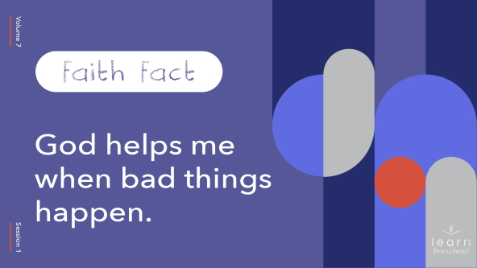

Sometimes when God helps us, it’s like He fights for us. Let’s practice our Faith Fact together. Make a fist *(make fist)* and punch the air *(shadow box)* to remind yourself that God can fight away bad things. Ready? **God helps me when bad things happen**. Awesome! Sometimes it takes a long time for bad things to go away. So now let’s punch and talk in slow motion. Ready? **God helps me when bad things happen.**

**Bible Time**

Wow! I love that our Faith Fact always teaches us something true about God and His Word. Let’s check in with Lizzy and see what else we can learn today.

• *Play* ***Bible Lesson Video A.***

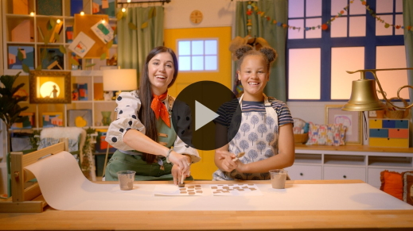

You’re doing such a great job learning our Faith Verse. This verse teaches us that we can face anything that comes our way because we get our strength from Jesus. That’s why we’re learning this Bible verse together.

**Worship**

When we take time to learn about God and His Word, it takes our attention off what’s going on around us. Bad things will happen to us, but we can focus on God and remember His promises to us. When we worship, we can show Him how much we love Him.

**Praise**

Are you glad that God is always with you? Shout yes! *(Group response)*

Are you happy that God helps you? Smile big and spin around. *(Group response)*

Let’s tell God that we love Him. Point up high and say, “I love You, God!” *(Group response)*

**Sing**

One way we show God how much we love Him is when we sing to Him. We can sing about how great and powerful God is. Let’s take some time to sing and worship God now.

• *Lead the kids in singing one or two songs. See song suggestions at the beginning of the session.*

**Prayer**

Wow! Listening to you sing is amazing. It makes me smile to hear you tell God how great He is. You want to know something really cool? *(Group response)* It makes God smile even more when He hears you worship Him. God also loves when we talk to Him. Let’s stop and talk to God now. Close your eyes and bow your head. Let’s pray.

|  |
| --- |
| Dear God, thank You for always being with us. Thank You for helping us when bad things happen. Help us to remember that we can do anything because You are with us. Amen. |

**Bible Time cont’d**

• *Play* ***Bible Lesson Video B.***

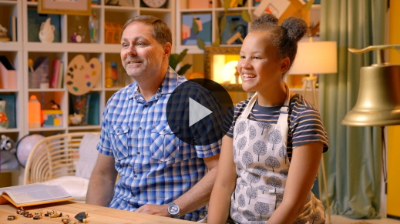

You did such a great job helping Lizzy solve today’s clues! Joseph was in a crazy situation. Who was mad at him? *(Allow responses.)* That’s right! His brothers were mad at him. Why were they so mad? *(Allow responses.)* Exactly! They were mad because of Joseph’s dreams. Joseph’s brothers also didn’t like that their father did extra nice things for Joseph, like giving him that special coat. His brothers turned against him, and sold him to travelers. Even when all of this bad stuff happened, Joseph wasn’t alone. I’m sure he was scared, but God was with him the whole time.

**Response Time**

• *Play a worship song quietly.*

Let’s take some time to respond to what we’ve learned today. We may not be in a situation like Joseph’s, but we may still be facing difficult things. For example, you or someone you care about may be really sick. People in your family might not get along with each other like Joseph and his brothers. Maybe you feel scared sometimes. Raise your hand if you’re facing something difficult like that right now. *(Group response)*

Thanks for letting me know that. I want you to know that you can trust that God is with you when bad things happen. Here’s something you can do when you need to remember that. Squeeze your hands together like this.

• *Clasp your hands together and squeeze them.*

When you squeeze your hands together, remember that God is with you. Let’s ask God to help us know that He will help us no matter what we’re facing.

• *Optional: Have the kids repeat phrases of the prayer after you.*

|  |
| --- |
| Dear God, thank You for always being with me. When things are hard or scary, help me to trust that You will be with me and help me no matter what happens. I love You. Amen. |

**Faith Verse**

One way we can learn to trust God’s promises is to memorize His Word. Let’s say our Faith Verse and do the actions together.

[Philippians 4:13](https://ref.ly/logosref/Bible.Php4.13) (NLT)

For I can do everything through Christ, who gives me strength.

• *Show the* ***Faith Verse Slide.***

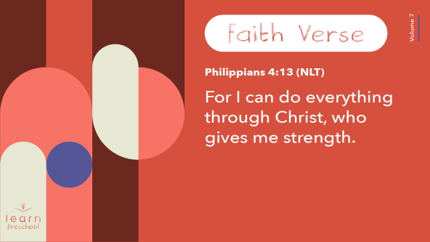

**Philippians** *(hands at waist, spread apart, palms up and out)*

**4:** *(hands together like a clap)*

**13** *(hands opened to “book”)*

**For I can do everything** (*two thumbs pointing at chest)*

**through Christ,** (*both index fingers pointing up)*

**who gives me strength.** (*both arms in “muscle” pose)*

Fantastic! You’re doing such a great job with our Faith Verse!

**Closing**

Who learned more about God today? *(Group response)* Me too! We worshipped and talked to God today. In today’s Bible story about Joseph, we learned that when bad things happen, we can trust that God will help us. He will never leave us alone. Doesn’t that remind you of our Faith Fact? *(Group response)*

• *Play the* ***Faith Fact Sound*** *video (bell ringing).*

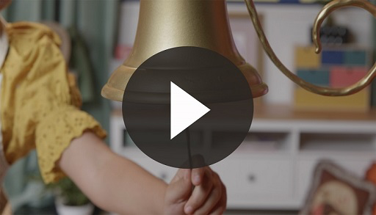

Let’s say the Faith Fact one more time. **God helps me when bad things happen.**

• *Show the* ***Faith Fact Slide.***



Sometimes we’ll face big problems, so let’s shout it together. Ready? **God helps me when bad things happen.** Sometimes we face things that aren’t so hard, so let’s say it as quietly as we can. Ready? **God helps me when bad things happen.**

**Dismissal to Small Groups**

Great job! Let’s go to our circles and keep learning together.

• *Dismiss the kids by groups*.

|  |
| --- |
| ***Leader Tip****: This can be done by assigning color teams or by age groups. Note that some young preschoolers may not know their age. Using a colored sticker, jersey, or wristband will help separate the kids and help identify their small groups.* |

**Small Group**

**25 Minutes**

*See supplies and prep instructions at beginning of session or in each activity below.*

|  |
| --- |
| ***Leader Tip****: Small groups can alternate to each circle, or all groups can do each activity at the same time. If you choose to alternate, you will need at least one leader per circle.* |

**Circle 1**

**Group Connection**

**God Helps Me**

|  |
| --- |
| ***You Will Need***   * *Colored sticker dots or stars, two to three stickers per kid*   *No prep needed for this activity.* |

Today, we’ve learned that God helps us when bad things happen. God can help us when we’re scared, sick, or feeling all alone. God can help us anywhere and everywhere. He helps us in the morning and at night. God is always with us.

• *Hold up the stickers.*

I have these colored stickers. I want each of you to tell me ways that God helps us. When it’s your turn to share, I’ll give you a sticker to put on your shirt. Let’s go!

• *Allow kids time to share ideas of how God helps them. Then, give them a sticker to wear.*

That reminds me of something important. Does it remind you of anything? *(Group response)* It reminds me of our Faith Fact. Let’s say it together. Ready? **God helps me when bad things happen.**

**Circle 2**

**Activity Page Time**

**Create-a-Coat**

|  |
| --- |
| ***You Will Need***   * ***Small Group Activity Page****, one per kid* * *Items to decorate (stickers, glitter pens, etc.)* * *Crayons, markers, or colored pencils* * *Glue or glue sticks*   ***Getting Ready***   * *Print copies of the* ***Small Group Activity Page****, one per kid.* |

Who remembers what gift Joseph’s dad gave to him? *(Allow responses.)* Joseph got a beautiful coat made of different colored fabric. I have a picture of Joseph wearing a new coat.

• *Hold up a* ***Small Group Activity Page.***

I think something is missing! What is it? *(Allow responses.)* There are no colors or fancy things on this coat. Hmm … Do you think you can fix that? *(Group response)*

• *Hand out copies of the* ***Small Group Activity Page*** *and supplies.*

You can make Joseph’s coat look however you want. You can make it your favorite colors or decorate it. Make this coat uniquely your design.

• *Give kids time to complete their pages.*

Wow! Your coats look so great. Isn’t it awesome to know that God will always be with you? Like He helped Joseph when bad things happened, He will help you and me.

• *During the activity, interrupt and practice the Faith Fact:* **God helps me when bad things happen.**

• *Play the* ***Faith Fact Sound*** *video. Review the Faith Fact even if you can’t play the sound.*



**Circle 3**

**Feet-to-Floor Game Time**

**Jump and Hop through Everything**

|  |
| --- |
| ***You Will Need***   * *Floor-safe tape*   ***Getting Ready***   * *Tape off at least four obstacle course activities (hopscotch grid, balancing line to tiptoe down, a gap to jump across, a chair to climb over, etc.).* |

Wow! What a fun day we’ve had so far. Who’s ready to play a game? *(Group response)* Awesome! Today’s game is about making it through challenges. You’ll have to hop, tiptoe, jump, and climb your way through this obstacle course. As you do each step, you’ll say a part of our Faith Verse. The rest of us will do the actions.

• *Demonstrate how kids will move through the activities and say each phrase of the verse:*

• [*Philippians 4:13*](https://ref.ly/logosref/Bible.Php4.13)

• *For I can do everything*

• *through Christ,*

• *who gives me strength.*

When you make it to the end of the course, shout, “Go!” and run back to the group. Then, the next person in line will face the same challenges. Don’t worry if you don’t know the whole Faith Verse yet, we’ll be there to help you if you need it.

• *Give kids a turn doing the obstacle course.*

You’re amazing! You never gave up and worked your way through every challenge. Let’s say our Faith Verse one more time together.

• *Lead group with the actions as you say the verse*.

[Philippians 4:13](https://ref.ly/logosref/Bible.Php4.13) (NLT)

For I can do everything through Christ, who gives me strength.

**Circle 4**

**Hands-On Learning**

**Faith Build**

|  |
| --- |
| ***You Will Need***   * *Four craft sticks per group*   ***Getting Ready***   * *Watch video of how to make a craft stick boomerang (*[*https://www.youtube.com/watch?v=5pHhXr7fBtM*](https://www.youtube.com/watch?v=5pHhXr7fBtM)*).* * *Practice making a boomerang.* |

Have you ever tried to do something really hard by yourself? *(Group response)* I have! I can normally get some of it done, but most of the time I get a little stuck.

• *Use three sticks to form a triangle as you share the following.*

In life, sometimes we find ourselves in hard situations. We may have to face some bad things like sickness or someone not wanting to be our friend anymore. When we try to make it through things like that all alone, it’s like trying to make this triangle stay together without anything to help it stick.

• *Attempt to pick up the triangle.*

It doesn’t work. When that happens, I could just give up. I could just throw these sticks away, or I could try something else to help me. Which do you think I should do? *(Group response)* Let’s keep trying!

• *Build a craft stick boomerang using all four sticks.*

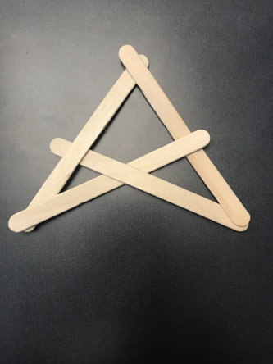

It worked! Adding that fourth stick is like what happens when we trust God to help us. We don’t have to try and do it on our own. When bad things happen, He can help us hold it all together.

When have you needed God’s help to face something really hard? *(Allow responses.)* Those were some pretty hard things that you needed help with. I’m glad we have God to help us!

• *Optional: Pray for the needs that the kids shared.*

**Dismissal**

• *Play the* ***Faith Fact Sound*** *video (bell ringing).*



• *Show the* ***Faith Fact Slide.***



You’ve done such a good job listening and participating today. Before we go, let’s say the Faith Fact together one last time. **God helps me when bad things happen.** Never forget that! I had a great time learning more about God with you. See you next time!

• *Send home the* ***Small Group Activity Page*** *with each kid.*

• *Remind parents that there are* ***Family Devotions*** *available on the app to do with their kid.*

• *Tell everyone the date and time for the next session*.